Minor Project (BTCS607N) Weekly Progress Report (Week-6)
Project Title: Vaari - Crop Water Footprint Information App
Phase 3 — Object-Oriented Design
Goal: Create the detailed class design of Vaari with methods, visibility, and logical packaging for the major components of the application.
1. Introduction
- Week 6 focuses on detailed class design and packaging.
- Unlike Week 3, this week adds method-level details, visibility, and responsibilities to the main classes.
- The purpose is to refine the static structure into a design that can be directly implemented.
2. Detailed Class Diagram
- The detailed class diagram expands the initial class diagram by including methods and access modifiers.
- CropViewModel handles UI requests and exposes crop data to the interface.
- CropRepository coordinates between the API service and local database.
- CropApiService defines network calls to fetch crop information.
- CropDao defines database operations for search history records.
- CropEntity and SearchHistoryEntity store crop and history data respectively.

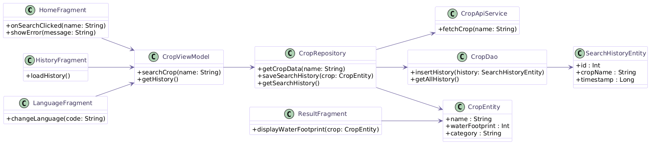

3. Package Diagram
- The package diagram groups related classes into logical modules.
- UI package may contain fragments and view models.
- Data package may contain repository, DAO, and entities.
- Network package may contain the API service and request handling.
- This organization improves readability, maintainability, and modular development.

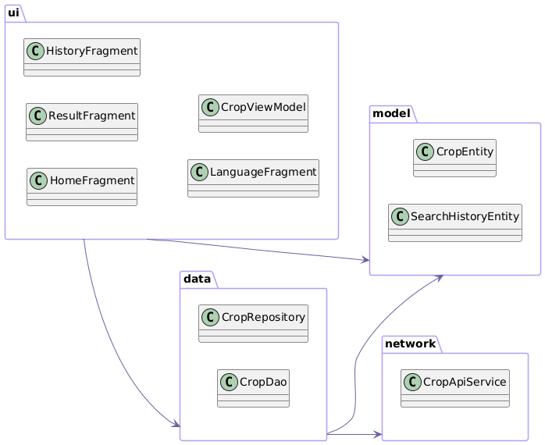
4. Design Improvements
- Add methods to each class according to its responsibility.
- Use visibility symbols such as + for public and - for private where needed.
- Organize the code into packages for UI, data, model, and network layers.
- Apply clean architecture thinking by separating responsibilities.
5. Scope of Week 6
- Week 6 is limited to design-level refinement.
- Implementation is still not the focus, but the diagram should be detailed enough to guide coding.
- The package structure and class responsibilities are finalized in this stage.
6. Deliverables
- Detailed class diagram.
- Package diagram.
- Class method and responsibility mapping.
7. Expected Outcome
- A complete design model for the core parts of Vaari.
- Clear class responsibilities and module organization.
- A strong foundation for architecture and implementation weeks.
8. Team Roles
- Team members will work on adding methods, grouping packages, and refining the object-oriented design for the app.

Mentor Signature _____________________ Project Guide Signature _____________________

